Project Development Phase
Model Performance Test
Date | 03 october 2026
Team ID | SWTID-2026-8181
Project Name | Script-Controlled ACL – Restrict Record Access Based on Field Value
Maximum Marks | 10 Marks
Model Performance Testing:
The Script-Controlled ACL is evaluated to verify correct record-access decisions, efficient ACL execution, and reliable validation for authorized and unauthorized users.
S.No. | Parameter / Values | Screenshot
1 | Metrics  • Access Decision Accuracy – Correct Allow/Deny decisions based on the configured field value.  • ACL Response Time – Time taken to evaluate the ACL script and return the access decision.  • Rule Execution Success – ACL script executes successfully without errors.  • Unauthorized Access Prevention – Users with non-matching field values are denied access. | 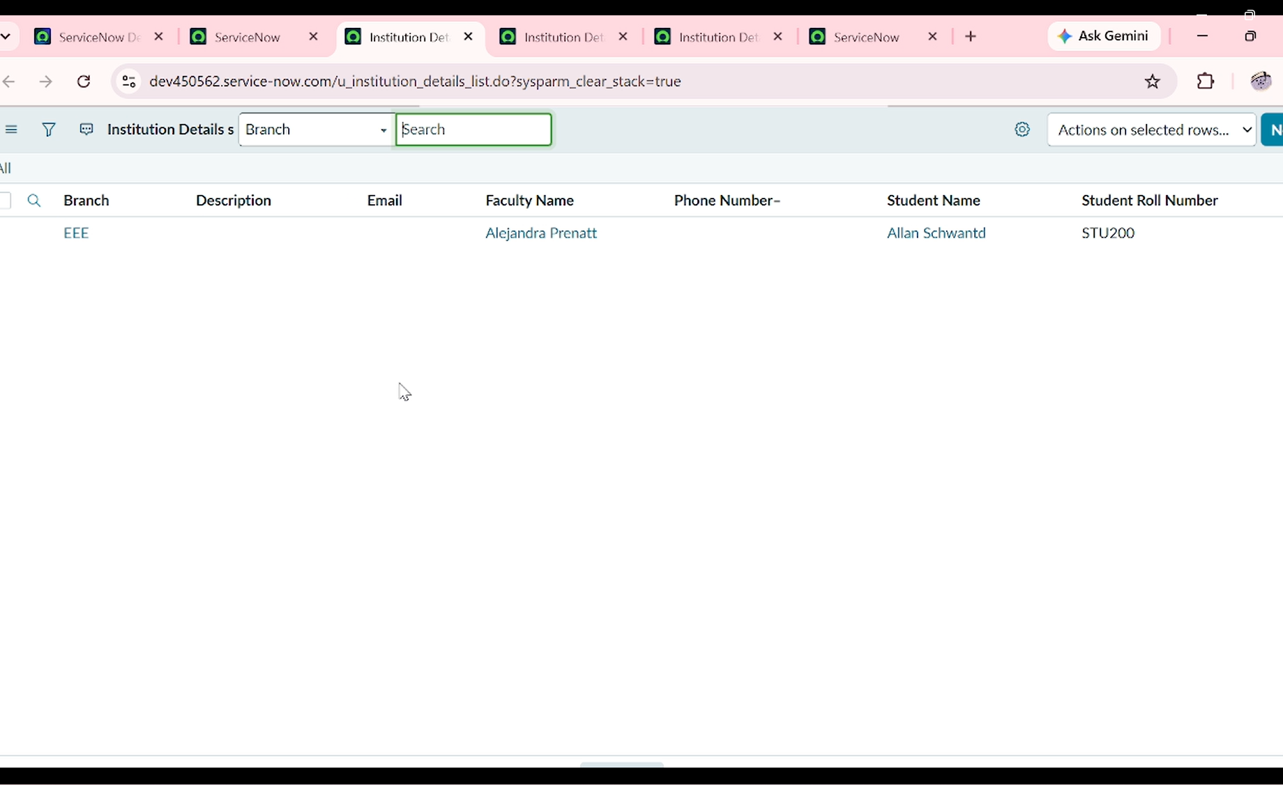
2 | Tune the Model / ACL Rule  • Optimize the field-value comparison logic.  • Avoid unnecessary database queries and repeated validations.  • Keep the ACL script simple, readable, and maintainable.  • Example: record.department == current_user.department → Allow; otherwise → Deny. | 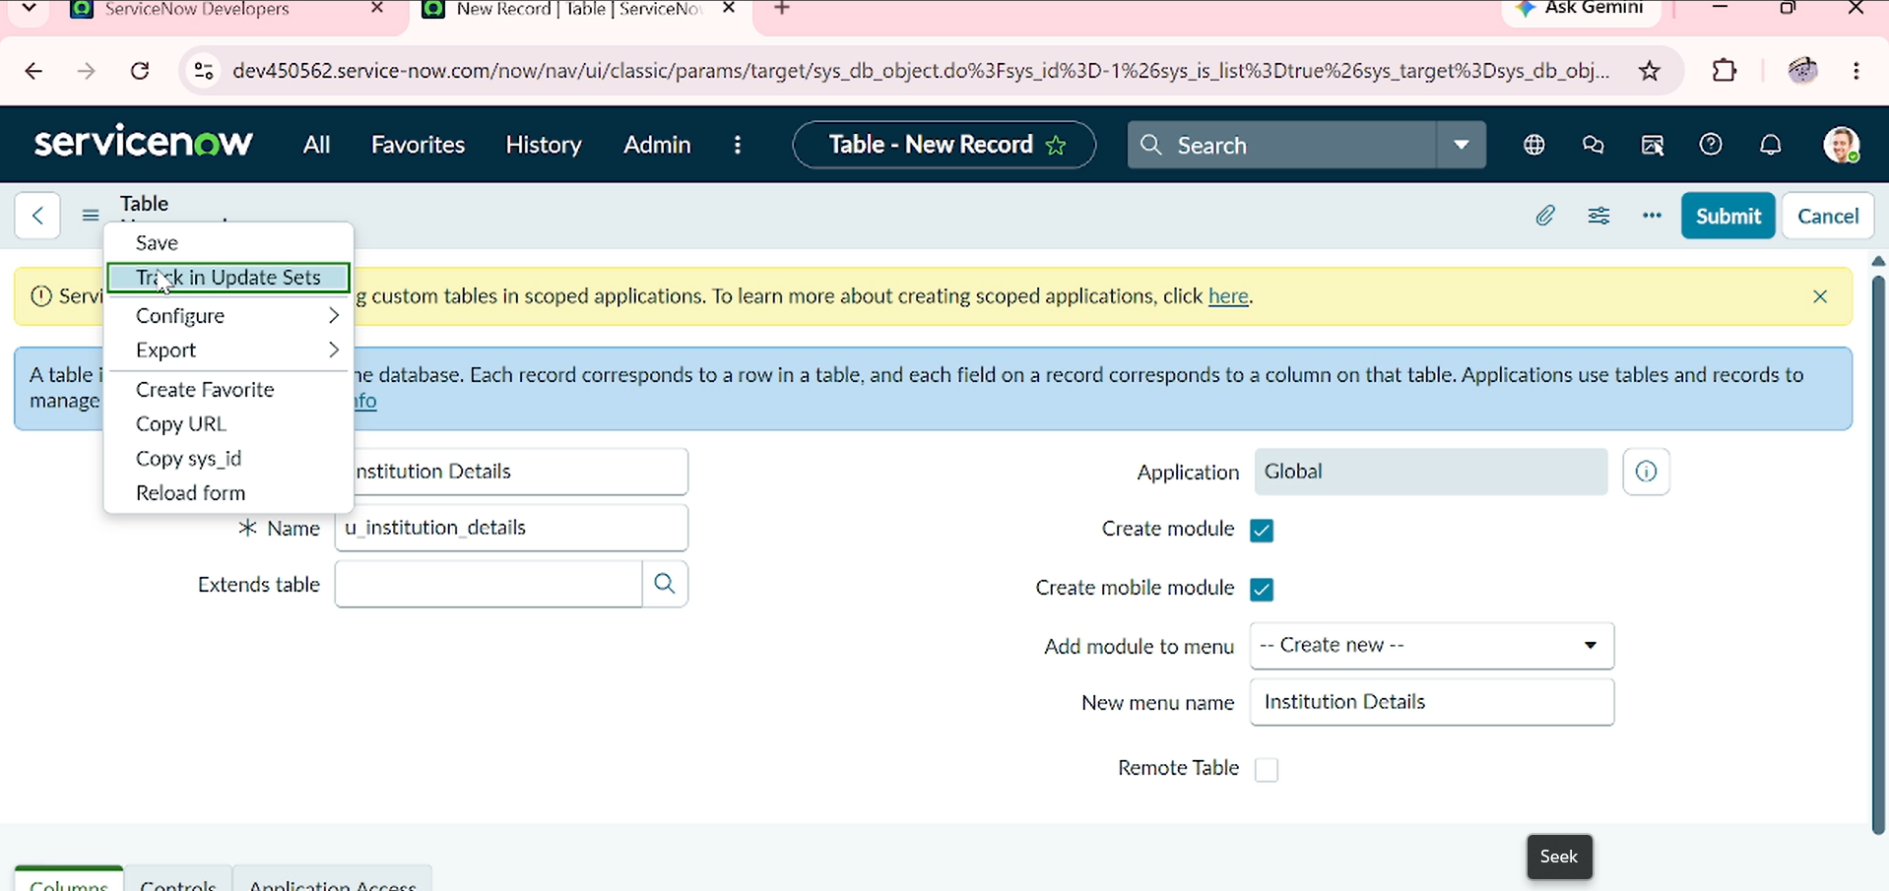
3 | Validation Method  • Positive Validation – Authorized user can access the matching record.  • Negative Validation – Unauthorized user cannot access the record.  • Boundary Validation – Missing or invalid field values are denied safely.  • Role Validation – Access follows the configured ACL role and rule. | 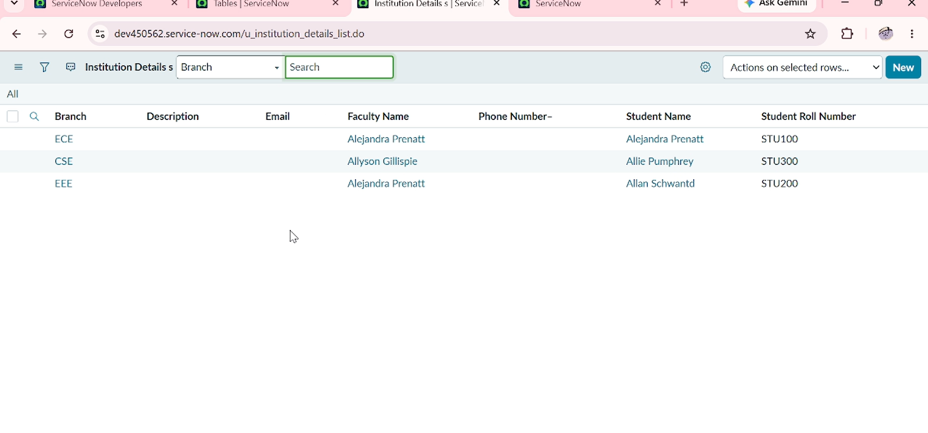
Screenshot Note: Replace the screenshot descriptions with actual screenshots captured from the ServiceNow ACL configuration and test execution.

